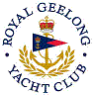 | Royal Geelong Yacht Club Inc.  Est 1859
Trophy Deed of Gift.

Trophy: | Niola Cup
Presented by: | Capt. S. A. Pidgeon
Date: | 1933
For:
Remarks / Revisions | 2008. Reassigned to Div 3 TWL Series
Click here for list Recipients

